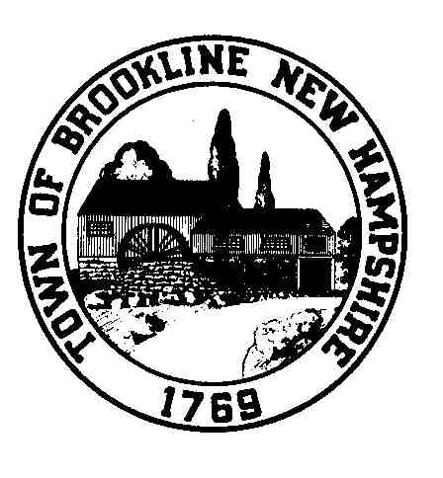

TOWN OF

BROOKLINE, NEW HAMPSHIRE
Cemetery Trustees

P.O. BOX 360 – 1 Main Street
BROOKLINE, NH 03033-0360

http://www.brooklinenh.us
Telephone (603) 673-8855

Fax (603) 673-8136

Brookline Cemetery Trustees Minutes
Wednesday, July 15, 2021

Meeting held in person at Town Hall

Attending:
Brian Rater, chair
Ann Somers, secretary
Judy Cook, member
Mike Wenrich, sexton

The meeting opened at 6:48 pm.
There was no public input.

The minutes from June 17th were unanimously approved as amended.

Update and next steps for North Cemetery stone wall
Mike reported that the new stone wall at North Cemetery, with the generous help of a number of town volunteers, is nearly complete. He will need to move some protruding stones from the north edge toward the south portion of the wall, and possibly bring in other large ones. He will notify the trustees when he has done so, and we will complete the wall.

Sign for North Cemetery
Judy has spoken with Eric DiVirgilio of Brookline’s Historical Society about the possibility of installing a permanent sign identifying North Cemetery. She will pursue this and report back.

Update on tree trimmings at Pine Grove and Lakeside
Mike reported that our local tree trimming contractors have full calendars and are not currently available, either for work identified as needed at Pine Grove, or for estimates for the Lakeside work we consider necessary.

Update on forms and packet
Mike remains in data-gathering mode toward a packet for future handout use, without time to focus on it currently. He has sufficient forms to maintain the necessary record-keeping.

Update/Discussion of adding gravel to cemetery roads
On hold, due to more pressing priorities for the BPW.

Discussion of cemetery fence needs at Pine Grove and Lakeside
Mike will talk with Gate City Fence for an estimate to complete the fencing at Pine Grove. This will provide a foundation for determining what direction to follow.

Update on Pine Grove documentation
Judy spoke of eventually (maybe soon) getting the Word file of burials moved into an Excel document (more familiar to most than is Access, another consideration). This will allow for much faster searching and sorting, and will provide easy links to photographs.

Judy’s goal is that access will be easy for Brookline’s town clerk, its sexton and the Brookline Historical Society, and ideally it will be available for viewing on the town web site.

Discussion of policy regarding planting trees and shrubs as monuments
We agreed that paragraph VI. C. of our Cemetery Rules and Procedures, which requires the written consent of the Sexton for the planting of trees or bushes, covers this recently-raised issue sufficiently. Considerations around roots and maintenance are essential components of approval.

Repair and cleaning of monuments
Judy is overseeing the cleaning, raising and repair of damaged and fallen monuments, currently at Pine Grove but with plans for North (the major leaning gravestone by the road) and Lakeside. With training Judy has undertaken and the availability of others who are fully experienced in the skill, two Wheeler monuments in the old section have been righted and “planted” for stability, and some others have been improved upon. More will be done while volunteers are available. Current volunteers are Dave Tiller and Mark Donahue of Andres Institute and Eric DiVirgilio of the Brookline Historical Society. Judy plans to contact Kevin Duffy of Cambridge regarding how best to repair the broken middle monument of the “Rockwood Five” along the southwest side of Sparrow Tucker Avenue.

Cemetery in the Woods kiosk cleanup
Judy is exploring sealing the wooden parts, and finding a source to freshen the display elements, or replicating them herself, perhaps to be completed by this fall.

Discussion of flat markers
There are many flat markers in Pine Grove that have been overcome by sod or soil. We agreed that over time we would like to raise them to be level with the ground once again. The ease or difficulty of each will depend on the way it was installed. Currently any efforts will be ad hoc.

The meeting was adjourned at 7:41 p.m. The next meeting will be August 19th at 6:45 p.m.

Minutes submitted by Ann C. Somers

